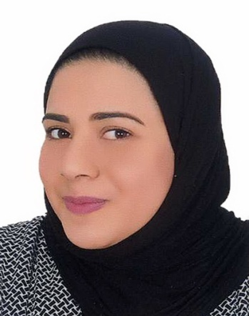MARYAM BAHAR

Flat 22 , BLD 720 , Road 4222 , Aali 742

**Mobile:** 34505718

**Email:** maryam.bahar.1994@gmail.com

Personal Profile

**Nationality:** Bahraini.

**Date of Birth**: 01/10/1994.

**Place of Birth**: Manama.

**Marital status**:Married.

Education

General secondary school certificate (Alnoor secondary school).

English language course from British Council.

Certificate in Retailing Principles (city & guilds).

**Work Experience**

( 2014 – Now ) I'm working as cashier at BMMI company, (Alosra supermarkets).

Certificate retailing practice of City & Guilds.

**Skills**

Management and leadership the work.

Attract customers and earn their attention.

Can handle complaints.

Working on Microsoft and social media.

Strives to do more and learn more.